**Purpose:**

This document is to set up API web key using Power BI

**Scope:**

This document applies to all data analysist and epidemiologist using an API web key using Power BI.

**Materials:**

|  |  |
| --- | --- |
| File Name | Location |
| FLUNET Dataset | <https://frontdoor-l4uikgap6gz3m.azurefd.net/FLUMART/VIW_FNT?$format=csv> |
| fluid Dataset | <https://frontdoor-l4uikgap6gz3m.azurefd.net/FLUMART/VIW_FID_EPI?$format=csv> |

**Prerequisites**:

* Must have Power BI Desktop
* Access to FlluNet/fluID API url

**Process:**

1. Open Power BI Desktop
2. Click Get data.

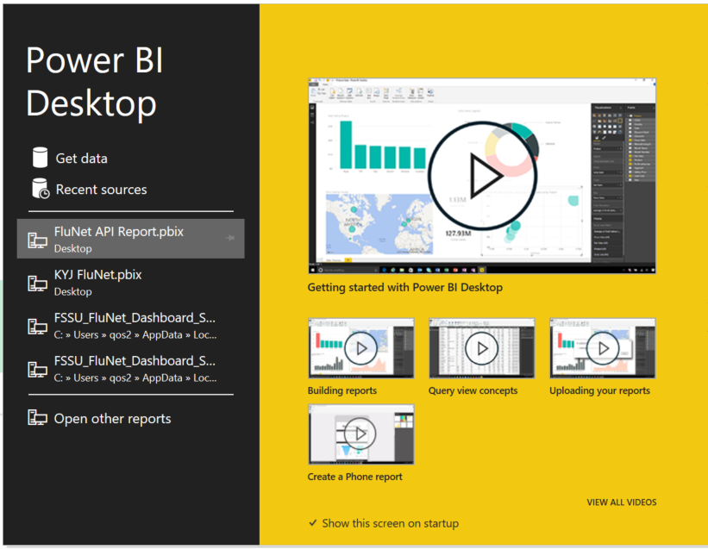

1. Search Web > Connect.

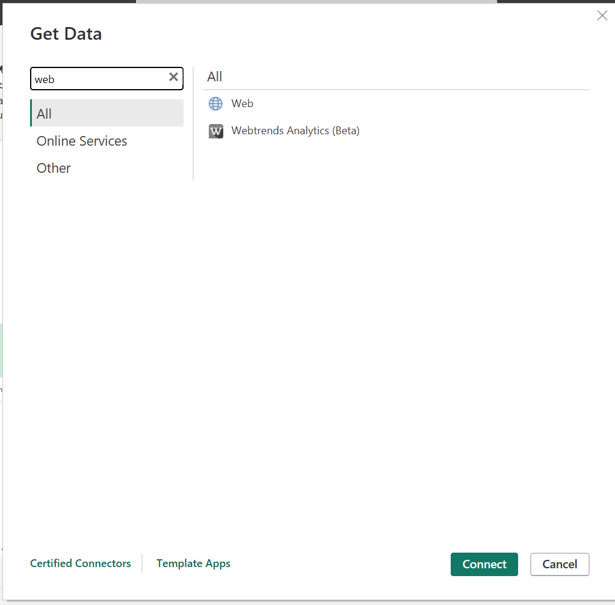

1. Add API url > OK
   1. FluNet: <https://frontdoor-l4uikgap6gz3m.azurefd.net/FLUMART/VIW_FNT?$format=csv>
   2. FluID: <https://frontdoor-l4uikgap6gz3m.azurefd.net/FLUMART/VIW_FID_EPI?$format=csv>

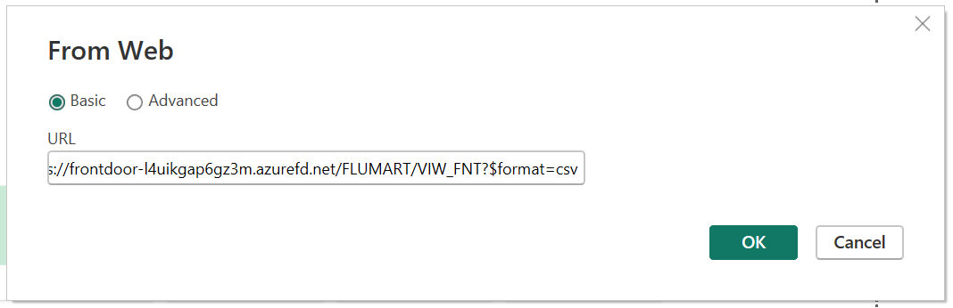

1. Data will load in table view.
   1. Load: if there are no edits.
   2. Transform Data: to make edits.

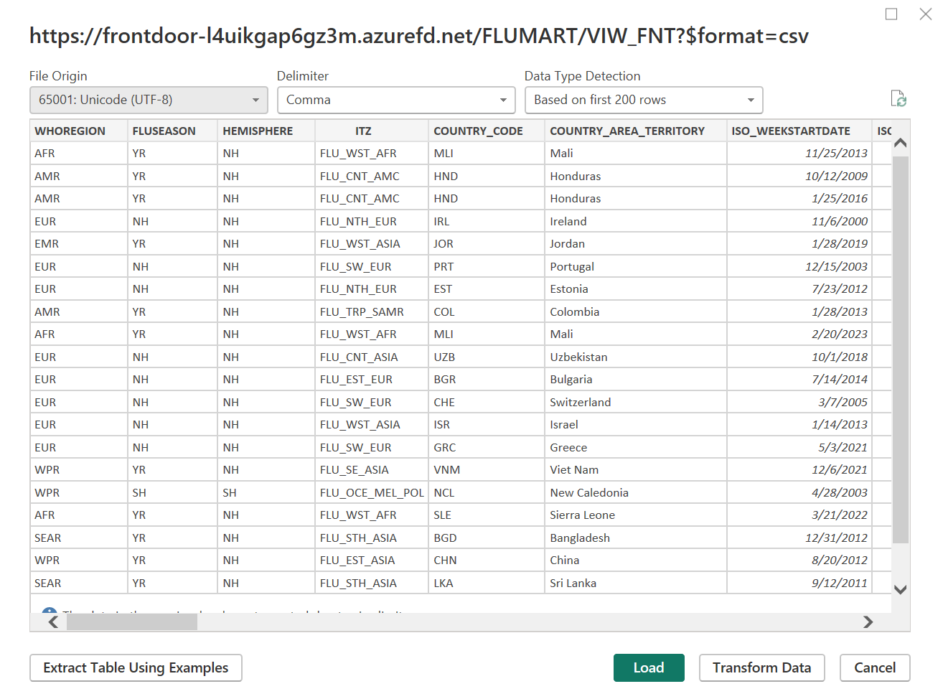

1. Data will begin to load

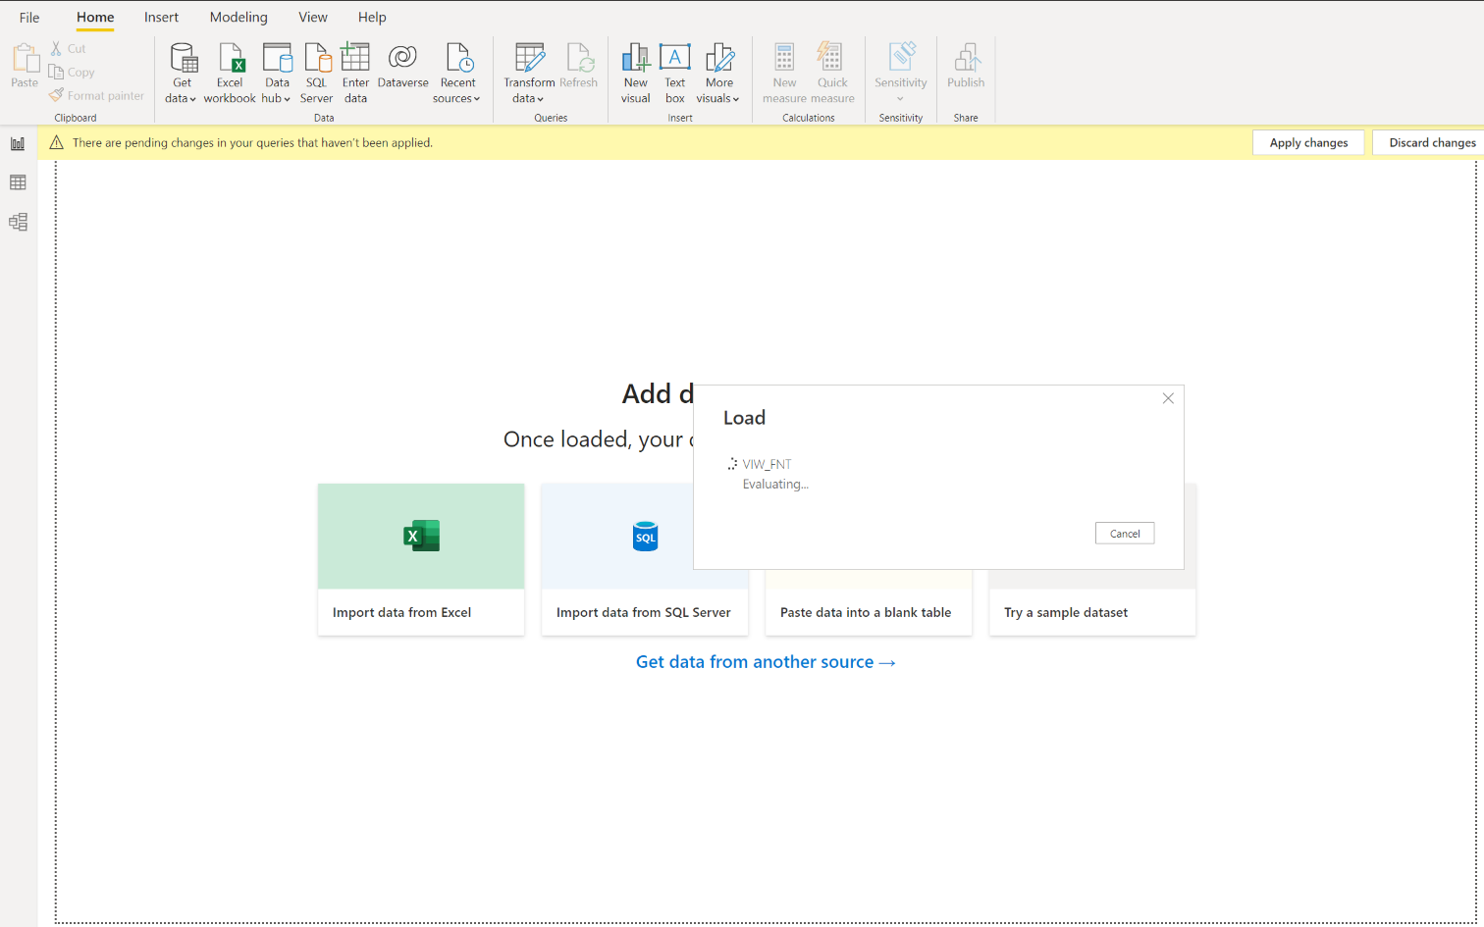

1. Power Query will alert if there was an issue with the loading of the data.
   1. Green check will show how many rows were loaded.
   2. Red flag tells you how many errors were detected.
   3. If there is just a connection lag the error will disappear.
   4. Clicking “view errors” link will show you what errors needs to be addressed.

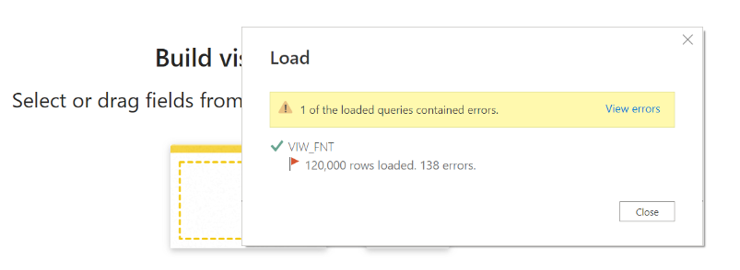

1. As you make changes you will see the changes in the right pane labeled “Applied Steps”
   1. If you have made an error, click on the x next to the step to remove and start over
   2. You can correct changes such as data types or column name changes.
2. Click “Close & Apply” to apply any and all changes.

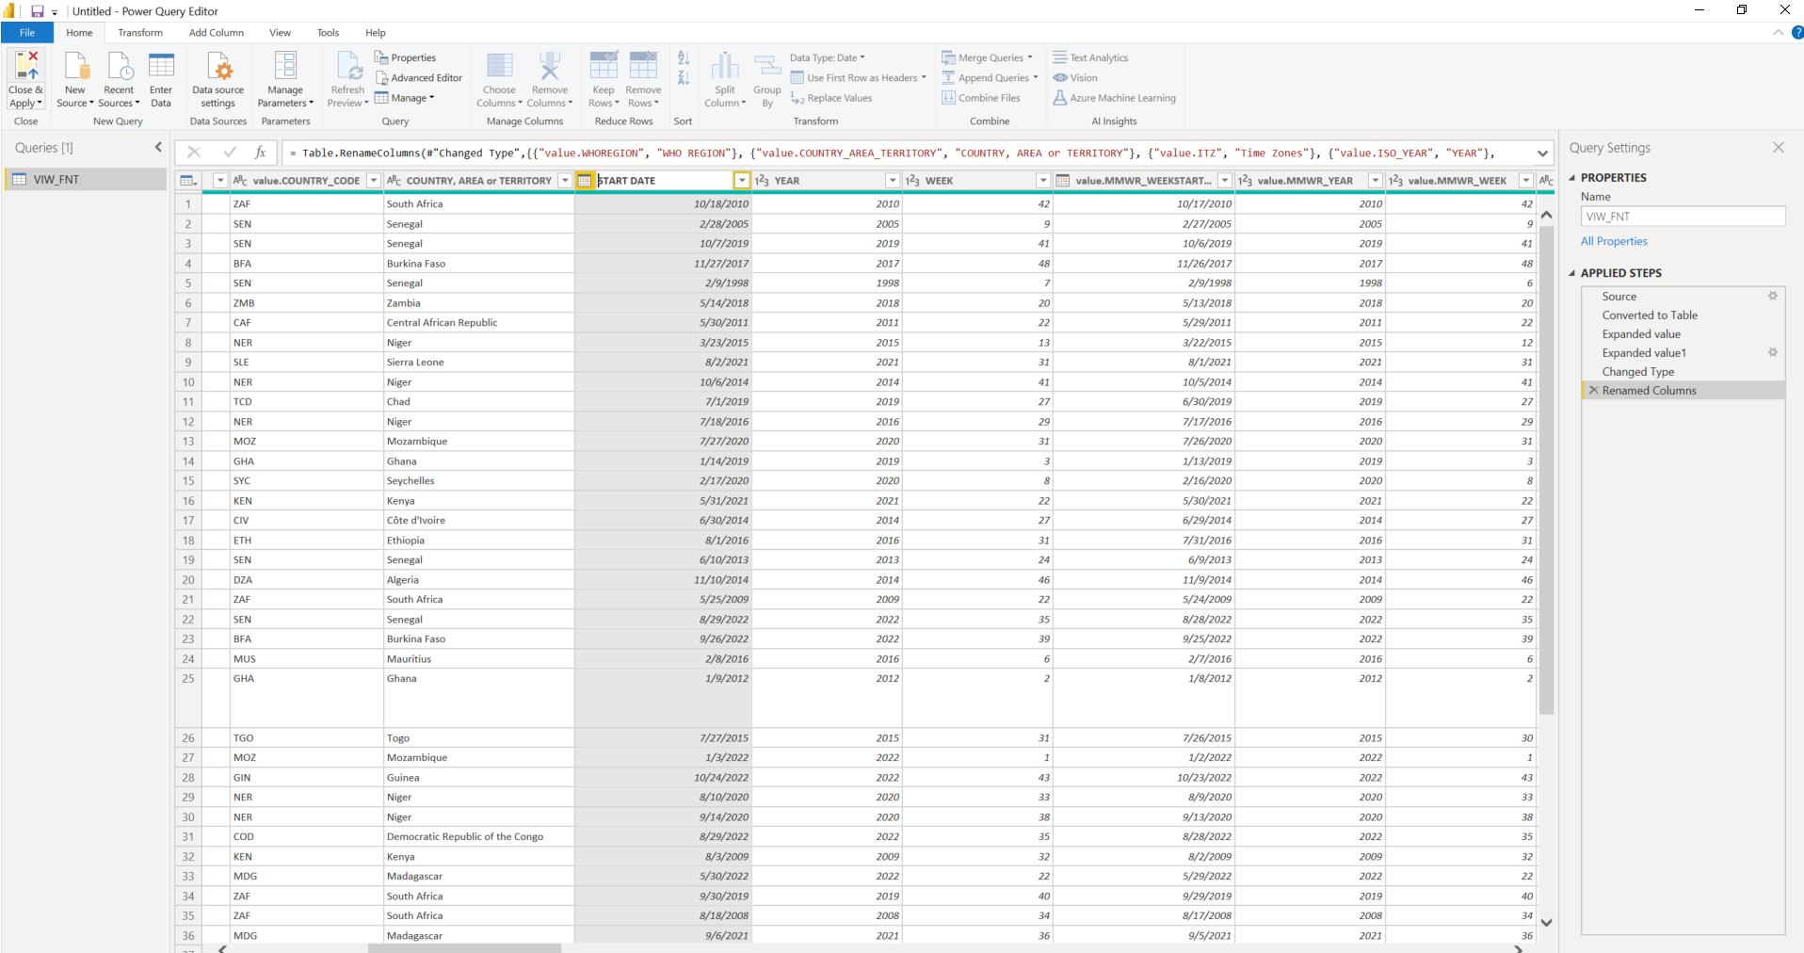

1. Click on the Report icon to the left of the screen.
   1. Data will show on the right side of the screen to begin using for your models.

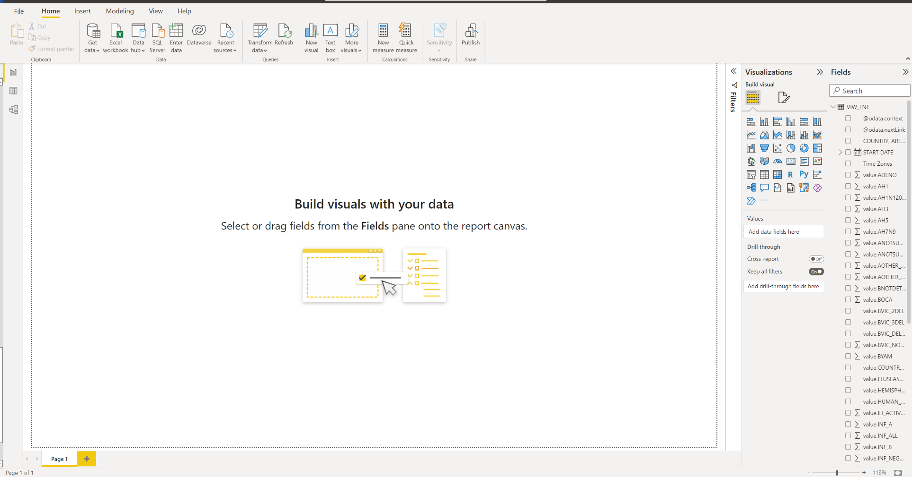

1. On the “Visualization” pane you can select the data visual you want to explore and start creating your data visuals.

